
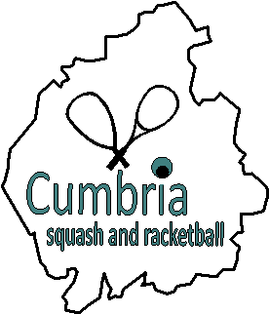
OVER 45, 50, 55, 60 & 65
COUNTY CLOSED MASTERS
2019-20 SEASON

TO BE HELD AT PENRITH SQUASH CLUB 8/9th February 2020

- Entry Fee: £10
- Entrants must be a member of a squash club affiliated to Cumbria Squash & Racketball.
- Preferred payment by bank transfer: Cumbria Squash, Barclays, 20-18-47, 20026689
- Alternatively, cheques: Cumbria Squash, c/o Chris Lilley, 14 Rimington Way, Penrith, CA11 8TG
- Entry Forms (scanned) to be sent to: Chris Lilley, chris356lilley@btinternet.com, indicating preferred age group.

- Dependent upon the number and age of entrants, it is intended to have five competitions:

Over 45’s, 50’s, 55’s, 60’s and 60’s

- If there are insufficient entries for any age group, some consolidation may be necessary.

- Closing date for entries: Saturday 1st February.
- All entrants will be advised by email of the draws, times, rules etc.
- Plate event will be held for all competitions – players will be automatically entered unless we are told otherwise.

-------------------------------------------------------------------------------------------------------------------------------

CUMBRIA SQUASH & RACKETBALL
OVER 45, 50, 55, 65 & 65 COUNTY CLOSED MASTERS
PENRITH SQUASH CLUB – 8th & 9th FEBRUARY 2020

NAME (Capitals): SIGNATURE:

ADDRESS: ENTRY FEE

Bank Transfer

Cheque
Email:

CLUB: Date of Birth:

Preferred Age Group: Over 45 Over 50 Over 55

Over 60 Over 65

